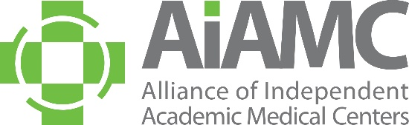

ALLIANCE OF INDEPENDENT
ACADEMIC MEDICAL CENTERS
2025 Annual Meeting
Call for Breakout Session Proposals

The medical education community is invited to submit a proposal for a breakout session at the 2025 AIAMC Annual Meeting, to be held March 20th – 22nd at the Loews New Orleans Hotel. We encourage you to share this call with colleagues, especially your residents who may not typically receive these announcements.

Breakout sessions must have a hands-on workshop format that provides practical tips on applying the principles presented in the plenary sessions and will be 75 minutes in length. Proposals are due no later than September 16, 2024, and all submitting presenters will be notified of the selection committee's decision in mid -October.

These breakouts will feature clinical learning environment leaders who have good stories to share. Session content should support the meeting theme of Thriving: The Power of One to Transform as follows:

- Well-Being/Thriving in Today’s Challenging Climate
- The Political Determinants of Health
- Leading From the Heart and Head
- Innovative Approaches to Medical Education/Medical Education as a Vehicle for Change

Breakout sessions should have a hands-on workshop approach and be highly interactive. Prior to submitting your proposal, please review the example provided of a prior breakout session proposal that was accepted by the selection committee. We hope this exemplar will be helpful to you as you develop your institution’s proposal(s).

A selection committee – made up of AIAMC members serving on the 2025 Annual Meeting Planning Committee – will determine which proposals are accepted. Submitters will be notified of the committee’s selections in mid-October. All accepted presenters are required to register for the conference*. In accordance with AIAMC policy, all registration fees and travel expenses will be the responsibility of the presenter’s home institution. Submitting a proposal is a commitment that, if the proposal is accepted, all proposed presenters will attend the 2025 Annual Meeting and conduct the session at the time assigned.

We encourage you to submit a proposal and look forward to seeing you at the meeting!

*Annual Meeting Registration Rates (these are 2024 rates and subject to change):
$800 AIAMC EARLY BIRD AIAMC Member Rate expires January 15, 2025
$890 AIAMC Member Rate January 16, 2025 – February 28, 2025
$700 AIAMC National Initiative IX Participant Rate
$275 AIAMC Member Resident Rate
$475 Non-Member Resident Rate
$995 Non-Member Rate
$450 THURSDAY Only Rate
$250 FRIDAY Only Rate
$300 SATURDAY Only Rate

